**ASSIGNMENT3: STATE SPACE PUZZLE**

**DUE DATE: 11:59 PM, 22nd March (Sunday Night)**

**Problem statement**:

Find out **all the solutions** to A-B-C jug problem.

You are given 3 jugs of capacities A litres, B litres, and C litres.

The initial state/initial volumes of water in the jugs is X, Y, and Z.

Your goal is to get to a final state of P, Q, R litres.

There are no markings on the jugs (you can’t just measure off litres directly).

You may pour from a jug to any other jug (you have to transfer from one jug to another until either one jug becomes empty or the other full) . You cannot waste water. The total amount of water in the entire system must be the same as initial.

You can use the skeletal structure of the code that Sir has given.

**Input format**:

A B C

X Y Z

P Q R

Sample input for 8-5-3 jug problem (sample input file is available in the folder):

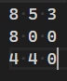

**Output format**:

Print all the solutions for the given problem. (For example if there are 3 solutions)

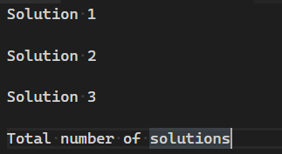

Each solution starts with the start state X Y Z followed by the intermediate states in every line and finally the final state.

Two such solutions for 8-5-3 jug problem with 4-4-0 as final state is (note that this should give you an idea of the output format):

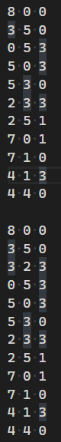

Notes:

We won’t give you a test-case where there are no solutions. So don’t worry about that.

To make sure your outputs are same, the order of the 6 transitions has to be this (so make appropriate adjustments to the callback array):

A->B

A->C

B->A

B->C

C->A

C->B

Files to be submitted:

For this assignment you need to submit four files: client, header, and implementation and readme.

A3_client_<SRN>.c

A3_header_<SRN>.h

A3_impl_<SRN>.c

A3_README_<SRN>.txt : Should contain the following:

* Data structures used.
* How to compile your code.
* Key takeaway from this assignment.

You can ask doubts at: [Doubts clarifications](https://docs.google.com/spreadsheets/d/1uepZktwcFP_s7xYlLxu8ZcKKgQaT9qeLUtdkfz1EzdA/edit?usp=sharing) (Use the assignment 3 sheet)

Submission link: <https://forms.gle/5FQRYAQdG2aYn2ss8>

**Late submissions are strictly not allowed.**